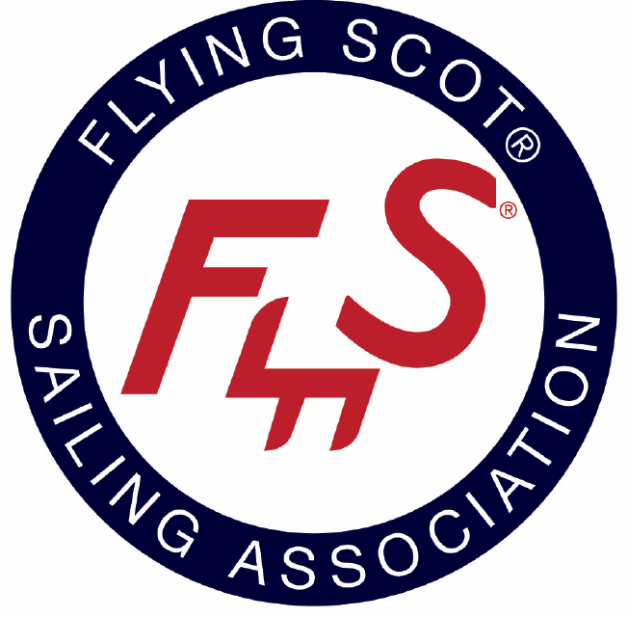

Wife-Husband Flying Scot Championship to be held on the Reservoir

Ridgeland, MS – Jackson Yacht Club welcomes sailboat racers from all over the country this weekend. It will be a picturesque scene as colorful spinnakers fill the Ross Bennett Reservoir. More than 34 race teams are expected to compete. The racing begins on Saturday and ends on Sunday.

The Wife-Husband Flying Scot Championship is annual regatta that is sanctioned by the Flying Scot Sailing Association. Sailing clubs submit bids to the association to host the event. This is the first time this event will be hosted by Jackson Yacht Club.

More event details can be found on the Regatta Network event page: http://www.regattanetwork.com/event/15389

About Jackson Yacht Club

Founded in 1960, Jackson Yacht Club is recognized as one of the South’s finest Yacht Clubs. JYC’s membership community offers dynamic sailing opportunities on the Ross Barnett Reservoir, a beautiful clubhouse and exquisite dining facilities.

JYC offers a family oriented atmosphere with several programs and social activities such as an competition sized swimming pool and adult and youth sailing programs.

About Flying Scot Sailing Association

The Flying Scot Sailing Association (FSSA) is the class association of the Flying Scot, a 19-foot centerboard sloop used for both family daysailing and racing. The Flying Scot is one of the oldest and largest one-design sailboat classes in the world. The late Sandy Douglass designed and built the boat and raced it for many years and the Flying Scot was inducted in the American Sailboat Hall of Fame in 1998. http://www.fssa.com/content/press-kit

Contact

To learn more about this event, please contact

Jim Leggette, Regatta Chair
Cell (555) 555-5555
jim.leggette@gmail.com

