NOTICE OF RACE

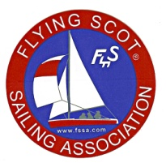
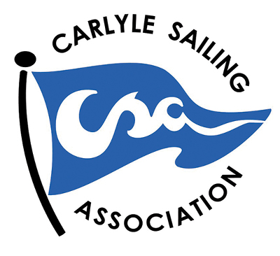
Flying Scot® 2015 Midwest District Championship,
the Annual Egyptian Cup Regatta and
a North Sails Racing Clinic
September 4-6, 2015

Host: The Carlyle Sailing Association (CSA)
Carlyle Lake, Illinois

Organizing Authority: Carlyle Sailing Association (CSA)
in conjunction with Flying Scot Fleet #83

Rules: This regatta will be governed by the Racing Rules of Sailing 2013-2016 (RRS), the rules of the FSSA (Flying Scot Sailing Association), including Article S-V and the race committee's sailing instructions. RRS 61.1(a)2 is deleted; all boats will comply with RRS 61.1.

Eligibility: The regatta is open to all Flying Scots BUT YOU MUST BE A MEMBER OF FSSA and a member
of a Midwest Fleet to compete for trophies in the Midwest District Championship. All others are eligible to compete in the Egyptian Cup regatta. Both regattas will be held concurrently.

Registration: Register by mail using the form available on the CSA web site (http://www.csa-sailing.org) or at the regatta site beginning Friday, Sept 4 at 6 pm. Sailing Instructions will be available to registrants at the completion of registration. Registration must be complete by Saturday, September 5, at 09:15 a.m..

Measurement: All boats may be checked for safety equipment and sail compliance as required by the FSSA class rules. (see www.fssa-sailing.org) Proof of current FSSA 2015 membership is required to compete in the Midwest District Championship.

Fees: The entry fee for the entire program is $65. There is a $15 discount for registration forms that are postmarked before August 15, 2015.

Schedule: This regatta will consist of five planned races, weather permitting.

Friday, Sept 4 9:00-4:00 pm North Sails Racing Clinic (schedule tbd)

6:00-8:30 pm Registration, Complimentary Bratwurst and Beer, North Sails racing clinic

Saturday, Sept 5 7:00-8:30 am Complimentary Continental Breakfast
7:15-9:15 am Registration
9:30 am Skippers’ Meeting
10:30 am First Race, possible back to back races
12:30 pm Lunch (at RC discretion)
2:00 pm Continue racing, possible back to back races
After Races Hors d’oeuvres, Wine and Cheese, and beverages
7:00 pm Dinner

Sunday, Sept 6 7:00-8:00 am Complimentary Continental Breakfast
8:50 am Continue Racing (Fifth Race if time permits; no start after 10:30 am) 12:00 pm Lunch and Awards presentation

Venue: Racing will take place on Carlyle Lake. Launching will be at the Carlyle Sailing Association (CSA). Boats will be stored on trailers on the CSA grounds in the appropriately marked areas.

Scoring: No races will be excluded from a boat's series score. This changes RRS rule A2, Appendix A. Low Point Scoring System shall be used. Five races are scheduled, of which one race will constitute a regatta.

Radio Communication: will be governed by FSSA rule; Art S-V (7)(c)

Awards: Trophies will be awarded to the skipper and crew as follows:
- Flying Scot Midwest District Championship: Top five finishes
- Flying Scot Midwest District Champion: First Place Traveling Trophy
- Egyptian Cup Regatta: Top five finishes
- Egyptian Cup Regatta Champion: The Egyptian Cup perpetual trophy (non traveling)

Disclaimer of Liability: Competitors participate in the regatta entirely at their own risk. See RRS 4, Decision to Race. Neither the organizing authority nor the host organization will accept any liability for material damage or personal injury or death sustained in conjunction with or prior to, during, or after the regatta.

Additional Information: Regatta registration information is available on the CSA web site (http://www.csa-sailing.org). For more information, please contact Mike Pitzer, Regatta Chairman, 314-283-1639, or email pitzerlaw@yahoo.com or contact Fleet Captain Jim Harris, 314-966-8404, email (jamesbharris@att.net).

