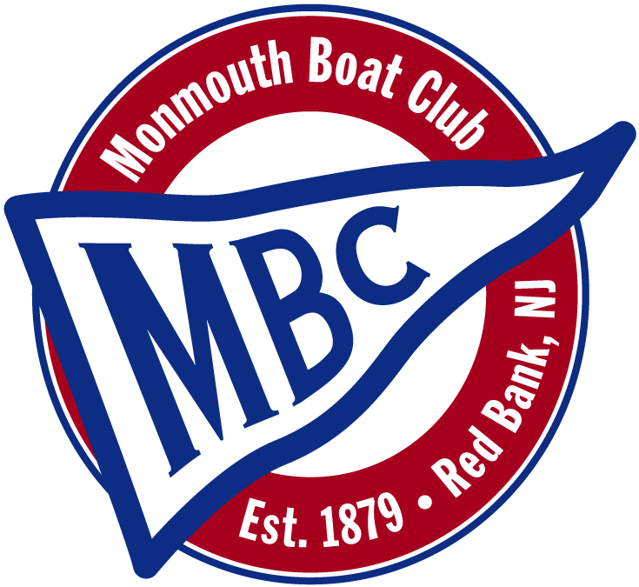 |  | Full Moon Regatta  June 6th 2015  Monmouth Boat Club, Red Bank, NJ
N O T I C E O F R A C E

- Rules
  - The Full Moon Regatta will be governed by the rules as defined in the Racing Rules of Sailing.
  - The rules of the Flying Scot Class will apply.
  - Certain rules may be changed and these changes will appear in the Sailing Instructions.
  - By participating in this regatta, a competitor grants to the organization authority and its sponsors the right to perpetuity to make, use and show, from time to time at their discretion, any photographs, motion pictures, and live, taped or filmed television and other reproductions of him or her during the period of the competition without compensation.

- Eligibility & Entry
  - The regatta is open to all boats of the Flying Scot Class.
  - Flying Scot Class Association membership is strongly encouraged.

- Boats/Measurement
  - Flying Scots will be used
  - Each competitor will be responsible for their boats being in compliance with the class rules.

- Schedule of Events
  - Up to five races are planned
08:30-10:00 Registration, check-in, and launching
10:00 Skippers meeting
10:15 Harbor gun, followed by Race 1 and subsequent races

- Fees
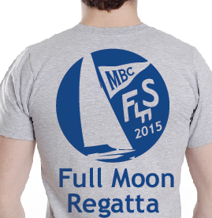
  - The entry fee is $45. The entry fee includes continental breakfast and lunch for skipper and crew, door prizes, and trophies. A $5.00 discount will be given to US Sailing members. No entry fee is assessed to boat-owning skippers participating for the first time.

  - Commemorative 2015 Full Moon T-shirts will be provided FREE to the skipper and one crew for advance registrations received by May 23. Additional T-shirts for a 3rd crew, sailing fans, or the kids may be ordered for $15 each. Shirt orders must be received by May 23rd for race day pick-up at the regatta.

- Advance Registration – Competitors shall register in advance by completing the Event Registration Form attached and also found on the web at www.monmouthboatclub.org on the Flying Scot Fleet page. Deadline for advance registration is May 23, 2015.

- Sailing Instructions – The sailing instructions will be available at registration.

- Scoring – A maximum of five (5) races are scheduled, of which one (1) shall be completed to constitute a series. No race scores will be excluded (no throw-outs).
- Prizes – Awards will be given to competitors placing first through fourth

- Disclaimer of Liability – Competitors participate in the regatta entirely at their own risk. See rule 4, Decision to Race. The organizing authority will not accept any liability for material damage or personal injury or death sustained in conjunction with or prior to, during, or after the regatta.
- Further Information –
Host Club: Monmouth Boat Club  31 Union Street  Red Bank, NJ 07701  732-741-9858 www.monmouthboatclub.org |  |  | Regatta Chair:  Marc Gordon  732-648-5733  zgums@comcast.net
 | Directions & Map

Directions: Take the Garden State Parkway to Exit 109.

From North: Turn left at traffic light, go under parkway and bear right to make jughandle turn onto Half Mile Road;

From South: Pass directly through the light at the bottom of the ramp (the middle of three options) and straight onto Half Mile Road;

Follow Half Mile Road to end. Turn right onto Front Street, Continue on Front Street, through a light, over water, and then through 5 more lights. Turn left on Wharf Avenue. This is the 1st left after the last light (Broad Street). Turn left again onto Union Street. Monmouth Boat Club is on the right at the bottom of the hill.

Host Club:
Monmouth Boat Club
31 Union Street
Red Bank, NJ 07701
732-741-9858
www.monmouthboatclub.org

Regatta Chair:
Marc Gordon
732-648-5733
zgums@comcast.net

Entry Form

Please print clearly and fill out entire form.
Skipper’s Name: Crew Name(s): ____________________________ ___________________________________
___________________________________
Address: __________________________________________________________
__________________________________________________________________
Phone: ___________________________Email:____________________________
Home Club or Fleet:__________________________________________________
Boat #: ___________ Boat Color: ____________ US Sailing #:________________

Entry fee: $45.00. A $5.00 discount will be given to US Sailing members. No fee for boat-owning skippers participating for the first time.

First two (2) exclusive 2014 Full Moon Regatta T-shirts are complementary with advance registrations. Additional T-shirts are $15. All orders must be received by May 30th. Enter quantities below:

Men’s:            __S __M __L __XL __2XL
Ladies cut:   __XS __S __M __L __XL
Youth:  __XS __S __M __L

My fee of $_______ + Additional T-Shirts $________ = Total $_______ is enclosed.

I agree to be bound by The Racing Rules of Sailing, the Flying Scot regulations and Sailing Instructions for this event. In consideration of being permitted to enter this event, being knowledgeable of the risks of competitive sailing and knowing that it is my sole responsibility to decide whether to enter or continue any race, I voluntarily assume the risk of participation in this event and release the host club, Monmouth Boat Club, and the people conducting the event from all liability in connection with any injury or damage that may occur.

Signature: ____________________________________Date: ___________

Mail with check payable to Flying Scot Fleet 157 to:
Eileen Nociolo
78 Forrest Ave.
Fair Haven, NJ 07704

