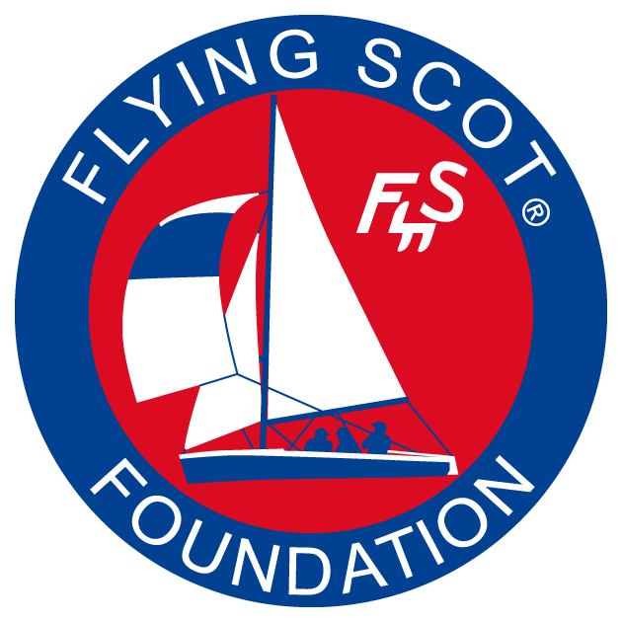
FLYING SCOT® FOUNDATION
FUND FOR EDUCATION
GRANT APPLICATION
Purpose: The Flying Scot® Foundation is a non-profit organization affiliated with the Flying Scot® Sailing Association. The Foundation has a Fund for Education that aims to bring new sailors into the fold. To this end, the Fund for Education is seeking to support sailing schools and community sailing associations (“Organizations”) that use a Flying Scot®(s) to train adults in basic sailing skills. These organizations must have strong support from a local Flying Scot® fleet and be willing to refer graduates to the fleet for further sailing experience. Fund support of these organizations can be cash grants, equipment, boat parts, sails etc…whatever will further the mission of training adults in Flying Scots®.
Instructions: Please fill out the application by typing in the “grey” areas. Leave blanks where you are unsure of the answer. Send completed application to: Buffingtoncw@gmail.com
Official Name of your Sailing School or CSA:

Complete street address including Zip code:

Responsible Officer (name and title):

Contact information for Responsible Officer including email and phone number(s):

Principal Instructor (name and contact information):

Instructors (including Principal):
Name | US Sailing Certified? | American Sailing Assn Certified? | Age | Full or part time?

Is the Sailing School or CSA an independent legal entity?

If part of another organization, please provide that organization’s legal name, address and the contact information of the President or Commodore:

Does your Sailing School or CSA have liability insurance?

What body of water does the Organization use to teach sailing?

Provide a list of the boats the Organization owns or uses for sailing education of adults:
Class of Boat | Hull Number | Condition | Owned or Borrowed?
Flying Scot®

Provide a sail inventory for your Flying Scot(s)
Sail | Age? | Condition?

Provide a summary of adults trained in Flying Scots® in the past 3 years:
Year | Number of Adults Trained | Estimate total number of lessons
2007
2008
2009
2010
2011 (projection)

Comments about adult training in Scots?

Provide the Fleet # and name and contact information for the Fleet Captain of the local Flying Scot® Fleet:

Give examples of how the local Scot fleet currently supports the organization:

How many recent graduates from your Organization have joined the local Scot Fleet?

GRANT PROPOSAL
Please tell us how the Flying Scot® Foundation can help your Organization. Clearly identify your current needs and tell how meeting these needs will further adult sailing education in your Scots (IMPORTANT).

Proposed start date of Grant

Proposed end date of Grant? (Generally one year later)

What is your plan to acknowledge the Foundation’s support?

BUDGET PROPOSAL
(Grants are generally limited to $2,000 per year per organization but this is negotiable.)

Budget Item | Cost each ($) | Cost per year ($)
Totals: | $ | $

BUDGET RATIONALE
Relate each expense to the objectives of the proposal.

Does successful completion of the project require additional resources that are not currently available?

What problems do you anticipate in completing the project?

If the proposed activity fails, what is your Plan B?

CERTIFICATION
I certify that funds received from the Flying Scot® Foundation will be used only for the purposes outlined above. I will keep careful records (including receipts) of all expenditures and prepare a detailed report at the end of the grant period for the Foundation. Any unused funds will be returned to the Foundation at the end of the grant period.

(Insert signature and title).

