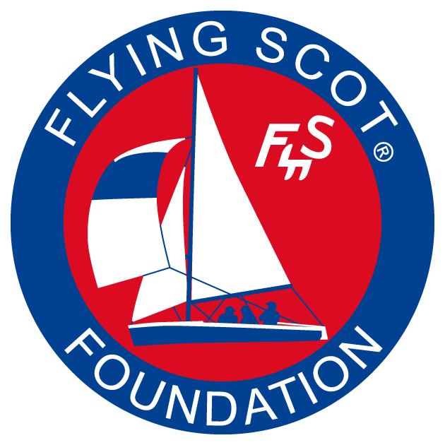
FLYING SCOT® FOUNDATION
Sail Donation Program
GRANT APPLICATION
Purpose: The Flying Scot® Foundation has refurbished Flying Scot® sails that are available for free to sailing schools and community sailing associations (“Organizations”) that use a Flying Scot®(s) to train adults in basic sailing skills. Instructions: Please fill out the application by typing in the “grey” areas. Leave blanks where you are unsure of the answer. Send completed application to: Buffingtoncw@gmail.com .
Official Name of your Sailing School or CSA:

Complete street address including Zip code:

Responsible Officer (name and title):

Contact information for Responsible Officer including email and phone number(s):

Provide a summary of adults trained in Flying Scots® in the past 3 years:
Year | Number of Adults Trained | Estimate total number of adult lessons
2009
2010
2012
2013 (projection)

Do you need a specific brand of Scot sail? If yes, which one?

How many main sails do you want?

How many jibs do you want?

How many spinnakers do you want?

What is your plan to acknowledge the Foundation’s support?

CERTIFICATION
I certify that sails received from the Flying Scot® Foundation will be used primarily to teach adult students how to sail.

(Insert signature and title).

