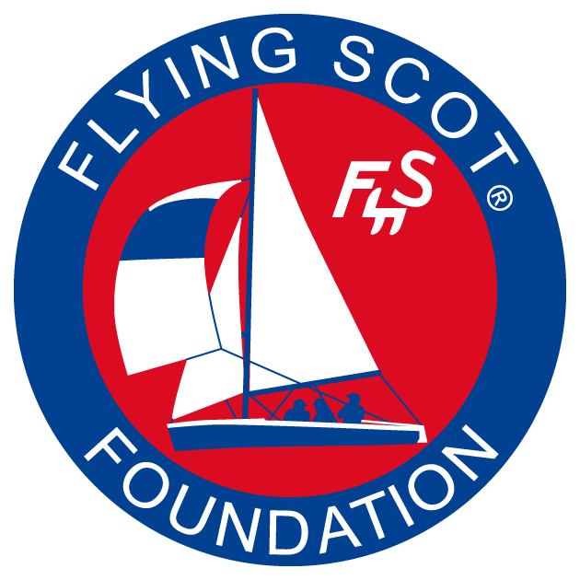
FLYING SCOT® FOUNDATION
GENERAL FUND
GRANT APPLICATION
Purpose: The Flying Scot® Foundation is a non-profit organization affiliated with the Flying Scot® Sailing Association. The Foundation has a General Fund that is designed to support Flying Scot® sailing. The assets of the General Fund may be used for purposes such as the following:
- to advertise and promote the sport of Flying Scot® sailing;
- to recruit new members;
- to help qualified Flying Scot® sailors attend US Sailing national events
- to help support Flying Scot® sanctioned regattas;
- to maintain and replace perpetual trophies;
- to provide Fleet Captains and District Governors with financial support;
- to provide enhancements to the FSSA Website;
- to enhance Scots n’ Water;
- to maintain and improve the FSSA historical archives;
- for any purpose that furthers the sport of sailing Flying Scot® class sloops

Note: IRS guidelines limit Foundation support to activities that have a clear charitable or educational value.
Instructions: Please fill out the application by typing in the “grey” areas. Leave blanks where you are unsure of the answer. Send completed application to: buffingtoncw@gmail.com

Official Name of your organization:

Complete street address including Zip code:

Responsible Officer (name and title):

Contact information for Responsible Officer including email and phone number(s):

What is your plan to acknowledge the Foundation’s support?

GRANT PROPOSAL
Please tell us how the Flying Scot® Foundation can help you or your Organization. Clearly identify your current needs and tell how meeting these needs align with the goals of the Foundation.

Explain the charitable or educational nature of the activity proposed (IMPORTANT).

Proposed start date of Grant

Proposed end date of Grant? (Usually one year later…)

BUDGET PROPOSAL
Budget Item | Cost ($)
Total

BUDGET RATIONALE

Relate each expense to the objectives of the proposal.

Does successful completion of the project require additional resources that are not currently available?

What problems do you anticipate in completing the project?

If the proposed activity fails, what is your Plan B?

CERTIFICATION
I certify that funds received from the Flying Scot® Foundation will be used only for the purposes outlined above. I will keep careful records (including receipts) of all expenditures and prepare a detailed report at the end of the grant period for the Foundation. Any unused funds will be returned to the Foundation at the end of the grant period.

(Insert signature and title).

