2024 Flying Scot Wife-Husband Championship – Atlanta Yacht Club 9/27-9/29/2024

CHAMPIONSIP DIVISION

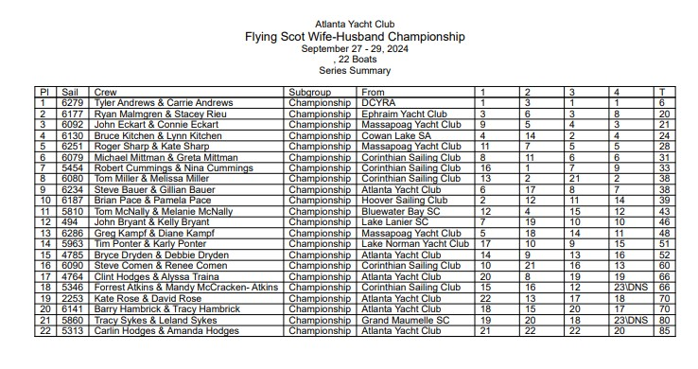

CHALLENGER DIVISION

