FSSA.COM – Online User Actions Last Updated 10/30/2023
Included here are instructions for (1) Adding an Account, (2) Viewing and Updating Your Account Data, (3) Resetting Your Password, and (4) Online Transactions - Join/Renew/Purchase/Donate. If you are a member, you may also (5) add content and (6) lookup and report on Member data.
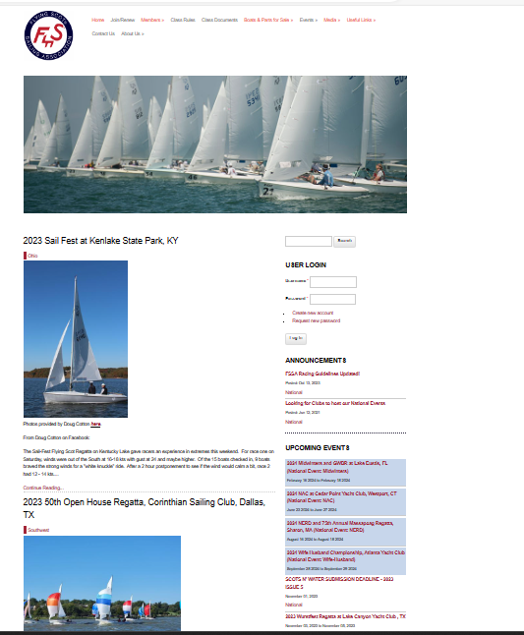

- To create an account on FSSA.COM
Navigate to FSSA.COM
- Under the User Login Section, Click on Create a new account
- Enter your desired Username
- Enter your email address
- Enter a signature (if desired) to be used if you add a Forum entry
- Enter your First Name (i.e Diane) or your Sailing Organization Name (i.e. Massapoag)
- Enter Your Last Name or your Sailing Organization Type (i.e. Yacjt Club)
- To make sure you are not a robot, you will be asked to enter the letters/numbers you see in the box
- Enter the code
- Click on create a new account
- You will receive an email with a link to finish creating your account where you can choose a password and enter your data – second name and email (if applicable), fleet, district, boat number, address phone number, etc. and click on Save. While you are there, you can click on Join/Renew to join the class!

- To update your data on FSSA.COM
Navigate to FSSA.COM

- Enter your username
- Enter your password
- Click the Login button
- Under the Welcome Back Section click on My Account
- Click on Edit to update your information OR Orders to view your online orders
- Modify the data you want to update or
- Click Save

When viewing orders, you will see any orders you placed in the system using the email that is on your member account. If you used a different email to place an order, you will not see the order here. Your order would be proof that you are a member even if your Last Join Year and Last Join Date has not yet been updated by an admin in the system.

- If you forget your password

Navigate to FSSA.COM
- Click on the Request New Password link
- Enter the email address that is on your FSSA account
- Click the E-mail new password button
- You will receive an email with a one-time link that allows you to reset your password and enter any other data on your account that you wish to change.
- Click on Save. While you are there, you can click on Join/Renew to join the class!

- To Join or renew your membership in FSSA.COM, make a donation to the Flying Scot Foundation, and/or purchase an item from the FSSA store:
Navigate to FSSA.COM
Click on Join/Renew
- To make a donation to the Flying Scot Foundation:

  - Scroll down to the red bar
  - Choose a donation amount
  - Click Add to cart

- To Join or Renew Membership in FSSA or buy items from the Store:

  - Scroll down and select membership type
  - Click Add to cart
  - Choose any other items you want from the Store
  - Click Add to cart

- When you are done choosing items
  - Scroll down and click view cart
  - Review scroll down and select checkout
  - In the billing information add your information (NOTE: if the email address matches the email address in your FSSA account, the order will be attached you your account).
  - Scroll down past Payment Method (you cannot select payment type here but will be prompted to later)
  - Click Review Order
  - Scroll down and click Submit Order
  - You will be taken to a PayPal screen
  - Blue Button is pay the PayPal
  - White button with blue text is Pay with Debit or Credit card
  - If you choose Debit or Credit you will still get a confirmation the PayPal transaction was successful. This is because PayPal is processing using your Debit or Credit card for FSSA.
  - If you have any questions contact Courtney Waldrup, Executive Secretary at info@fssa.com

Once you have joined or renewed, you are granted the Member Role in the online system. With the member Role you can add certain content and you can look up and report on member data. An admin will enter your FSSA Join Year and Month if you are a new member and will update your last Join date, your FSSA Status. whether you requested online only Scots ‘n Water or a membership card.
MAIL-IN OPTION: If you prefer to mail your application, please go to https://fssa.com/node/7661 to download a copy of the Membership Application that you can mail to FSSA with your Check for the appropriate amount. The mailing address is:

Flying Scot Sailing Association
One Windsor Cove, Suite 305
Columbia, SC 29223

- Adding Content on FSSA.COM

If you are a current member, you are allowed to publish certain content on FSSA.COM. this includes Articles, Classified Ads, Calendar Events, Forum Topics and Regatta results.

Navigate to FSSA.COM
- Login to your account
- Under the Welcome Back section, Click on Add Content
- Choose the type of content you want to add
- Follow the prompts for the required information and be sure to click on Save. If you are adding an article, don’t forget to click on the box that says Publish to Home Page.
- For details there is a tutorial on the website that you can view to get detailed instructions:

Creating Content | Flying Scot Sailing Association (fssa.com)

- Member Lookup and Report

If you are a current FSSA member, you may look up or report on FSSA member data

Navigate to FSSA.COM
- Login to your account
- Under Members, Click on Member Lookup and Report
- You may lookup members by last name, email address, District. Fleet or sail number – enter the data you want to search and click Apply
- If the data exists for that member/members, their record appears at the bottom of the screen

To report on members, click where it says “To export all member data in CSV format, click here”

- The data is downloaded to a CSV file that you can open in Excel and filter and sort by any field in the report. All data from 2020 through the current date is exported to the report
- NOTE: The FSSA Status tells you when the person last joined. If a person says they have joined, the Admin may not have updated this field yet. They can log in and look up their orders online and show that they joined recently but just have not been updated by an admin yet.

