To donate to Flying Scot Foundation and receive chance(s) to enter a raffle for a brand new Flying Scot, you may do this online at http://fssa.com/ and instructions for that are further down in this document. You may also put a check in the mail and fill out this form:

Name ___________________________________________________________________

Street Address ____________________________________________________________

City ___________________________________ State _____ Postal Code ____________

Phone Number ____________________________

Email address ____________________________________________________________

Amount of check (in multiples of $100) ___________________

Make your check payable to FSSA and mail to:

FSSA
Courtney Waldrup
1 Windsor Cove, Suite 305
Columbia SC, 29223

You will receive a receipt via email, or via USPS mail if you don’t have email, and you will be entered the appropriate number of times in the raffle. Good luck!

To donate to the Flying Scot Foundation online at http://fssa.com/ towards one or more chances to win a new Flying Scot. If you have ANY issues, click “Contact” at the top of the page and you can request some help.

- If you already have an account on FSSA.COM, log into your account and proceed to (3)

- If you do NOT already have an account on FSSA.COM, you must register on the site to participate in the raffle online. You can do this from the FSSA.COM home page – click “Create New Account”. The process includes waiting for an email that allows you to continue the process. If you have ANY issues creating your account, click “Contact” at the top of the page and you can request some help. Once your account is established, proceed to (3)

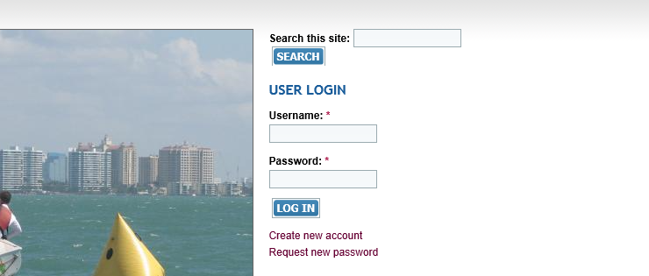

- Choose “Join/Renew/Donate” at the top of the page:

- Scroll to Flying Scot Foundation DONATION and click “add to cart”

- Choose an amount in multiples of $100.00 and for Donation Dedication type “Raffle”

- Click “add to cart” again

- If you are done, click “Checkout”

- Fill in your name and address. Phone number is optional, but please enter it since we will want to call you if you win!

- Choose a payment method
If you choose PayPal, you do not have to have a PayPal account, you will be allowed to enter a credit card number. If you choose personal check, you will be given information on where to send the check.

- Click “Review order” and check the information to ensure you have entered everything correctly

- Click “Submit order”

- You will receive a receipt via email within a few days and you will be entered the appropriate number of times in the raffle. Good luck!

